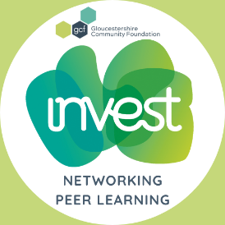
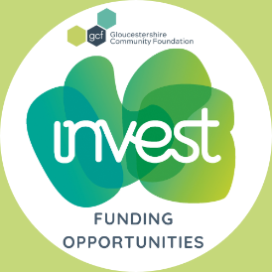


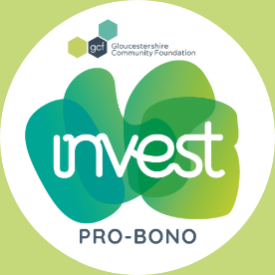
INVEST Programme – for Charities

Thank you for your interest in our INVEST Programme for Charities, a skilled resource and support service that helps you develop your business, sustainability and growth.
Gloucestershire Community Foundation (GCF) continues to provide much needed skilled resources to our charitable groups, with the INVEST Programme now in its fourth year.
Through INVEST Mentoring, we have mentored 33 charity leaders and now we launch an exciting new addition to the programme, INVEST Pro-Bono Programme supported by exciting opportunities for Funding, Workshops & Networking.
INVEST Mentoring - Open to Charity Leaders, Managers and Chair of Trustees: provides mentors from the business community to charity leaders, charity chairs, and managers in the county. The aim of the mentoring programme is to provide a listening ear and a helping hand, someone outside your organisation, a critical friend to help with decision-making, enrich your network and boost your confidence, that may lead to more strategic working, business planning or income generation.
INVEST Pro-Bono - Open to all organisations: the service connects businesses with local voluntary and community groups to share their skills, professional advice and services, helping to strengthen the vital services charitable groups deliver for our local communities.
INVEST Funding Opportunities, Workshops, Networking and Peer Learning - Open to all organisations: You may not need specific support at this time, but by joining INVEST, you will get priority invites and opportunities for funded workshop places & events, you will also be first to hear about new funding opportunities through this programme.
Please note, you only need to fill out your contact details for this option.
The first step is to fill out the form below sections A&B - confirming your details and the support that you need. Please note, you are welcome to select all that you need, both the mentoring and pro-bono or just one, and if these are not required at this time, do tick the other, and we will keep in touch with upcoming opportunities available.
Next steps
For Mentoring and Pro-bono support, our CEO Talitha Nelson will be in touch to discuss your needs and answer any questions you may have.
We look forward to hearing from you!

Charity – Registration form

Name of organisation
Type of organisation
(e.g. charity, CIO, CIC, social enterprise, other not for profit)
Charity number/s or Company registration
Brief description / operating sector
(e.g. homelessness, mental health etc)

Charity/organisation website
Charity/organisation annual income
Address
Contact name
The name of the person writing and submitting the application/registration
Job Title
Your role within the charity (eg CEO, Director, Centre Manager, Charity Founder, Chair of Trustees)
Contact telephone number
Email address
Date application submitted

Please check the box to confirm what support or service you would like (tick all that are applicable)
Mentoring Pro-bono Funding Opportunities/Workshops/Networking/Peer Learning

SECTION A: MENTORING + PRO-BONO - Please complete each question below in no more than a 100 words.
Please give a brief description of your role.

Please provide a clear description of the type of work that you need help with.

If you require mentoring support, please tell us how you would benefit from having a mentor?
- What are some of the issues you’re currently experiencing that you’d like to address as part of the mentoring process?

- Briefly describe some of your professional goals over the next: 12 – 24 months

- Background of Charity – please tell us about your organisation, how your role contributes and fits into the overall structure

- Briefly provide information about your career to date, including your key achievements and challenges

- Please tell us a little about your interests and any personal information that maybe helpful to matching you with a Mentor

If you require pro-bono support, please tell us the area of expertise you need help with?

☐ | HR – health checks, policy & procedure reviews, employment and recruitment advice
☐ | Legal – commercial property lease reviews & negotiation, data protection & privacy policy updates, intellectual property protection, changing legal structures, updating Articles of Association
☐ | Professional building services – design, surveys, property & market rates advice, capital project management advice, structural engineering, valuations, planning advice
☐ | Communications & creative design – branding, copywriting, website design, digital strategy, SEO & Google analytics training, design software such as Canva
☐ | IT - software training e.g. Microsoft Teams & advice on CRM systems, cyber security, AI
☐ | Business planning - strategy, coaching and mentoring, facilitation, financial management systems
☐ | Non-detailed financial, tax or VAT advice

How did you hear about the INVEST for Charities Programme?

SECTION B: AGREEMENT OF CHARITY
Volunteer expenses
Our INVEST service is free to voluntary organisations; all we ask is that you cover our volunteers’ expenses, such as travel where appropriate. The nature and level of these expenses and how they should be claimed must be agreed at the start of the project between the charity and the volunteer.
Publicity
GCF uses general write-ups of projects carried out by its volunteers for publicity purposes in fundraising and recruiting new volunteers. Detailed descriptions of client charities or the content of the projects are not made public. Please let us know if you would prefer your organisation or project not to be mentioned in our “client list” or in other material (e.g. newsletters).
Ownership of Intellectual Property & Confidentiality
All intellectual property and related material, including any trade secrets, moral rights, goodwill, relevant registrations or applications for registration, and rights in any patent, copyright, trademark, trade dress, industrial design and trade name (the "Intellectual Property") that is developed or produced during this project, will be the sole property of the Organisation. The use of the Intellectual Property by the Organisation will not be restricted in any manner. Once the project has concluded, GCF and the Volunteer Consultant will return to the Organisation any documentation, records, or confidential information which is their property which is requested by the Organisation.
Confidential information refers to any data or information relating to the business of the Organisation which would reasonably be considered to be proprietary to the Organisation including, but not limited to, accounting records, business processes, and organisation records and that is not generally known in the industry of the Organisation and where the release of that confidential information could reasonably be expected to cause harm to the Organisation. GCF agrees that they will not disclose, divulge, reveal, report or use, for any purpose, any confidential information which GCF has obtained from the Organisation or the Volunteer Consultant, except as authorised by the Organisation or as required by law. The obligations of confidentiality will apply during the term of the project and beyond.
Organisation and Volunteer Consultant’s Feedback
GCF’s vision is for all voluntary organisations to have the management expertise they need to help them thrive. As a charity we rely solely on income generated from our fundraising activities. Without your feedback, we are unable to monitor and evaluate our services for funders, putting our valuable services in jeopardy. Taking time to complete and return your feedback survey means other charities, like yours, will be able to benefit from our free services in the future.

I understand that as a GCF Mentee I am required to commit to completing the mentoring programme with my mentor, as set out in the GCF Trust Mentoring Guide.
Name and Role of Mentee
Signature
Date

Thank you and we look forward to working with you.
Once you have completed the form, please return it to Talitha Nelson INVEST@gloucestershirecf.org.uk
________________________________________________________________________________________

This section will be filled out by the INVEST Co-ordinator.

Mentoring Assignment- For INVEST Co-ordinator | No.

Notes completed by INVEST for Matching Mentee and Mentor

