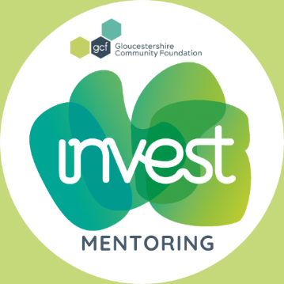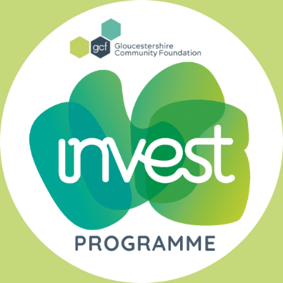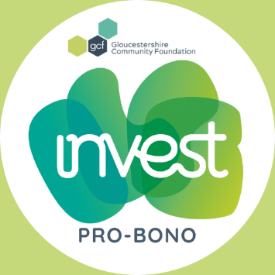
GCF’s INVEST Programme – Mentoring & Pro-Bono
The county’s professional skills volunteering programme – delivering social value.
Share your expertise with local charities & community groups in Gloucestershire.
There are times when charities & community groups need more than funding. They are often in need of support with specific areas that require professional expertise and services such as:
- Mentoring – Individual personal development, be a listening ear and helping hand – (more information shared, once the box is ticked)
- Business planning - strategy, coaching, facilitation, financial management system
- Communications & creative design – branding, copywriting, website design, digital strategy, SEO & Google analytics training, design software such as Canva
- HR – health checks, policy & procedure reviews, employment and recruitment advice
- IT - software training e.g. Microsoft Teams & advice on CRM systems, cyber security, AI
- Legal – commercial property lease reviews & negotiation, data protection & privacy policy updates, intellectual property protection, changing legal structures, updating Articles of Association
- Professional building services – design, surveys, property & market rates advice, capital project management advice, structural engineering, valuations, planning advice
- This is not an exhaustive list
GCF’s INVEST Programme matches these organisations with businesses and individuals who want to volunteer their time, skills and expertise to make a social impact.
Any business can get involved. Our team have in depth knowledge of the voluntary sector in Gloucestershire and can advise you on current initiatives and issues across the region. We will make the introductions and help you to grow your connections with the “impact sector.”
Who we help
GCF’s INVEST Programme supports both new and established charities and community organisations that are:
- Based and operating in Gloucestershire
- Working to strengthen communities experiencing inequalities and disadvantage; and or improve the lives of local people who face difficulties and have limited access to appropriate or affordable services and support.
We support small local charities and community organisations which may not be able to afford some professional services. This means we will prioritise those with an income under £1 million, particularly those with an income under £0.5 million.
How it works
- We will work with you as a company or individual, to understand the types of skills, services and time your business or you, may be able to offer. You will be provided with an INVEST logo that you can use to promote your involvement and the programme and share your involvement on our socials.
- We will then share any volunteering opportunities that may be relevant to you, as and when charitable organisations contact INVEST for support.
- If you or another employee would then like to have an informal chat with us or the charity about a particular opportunity, we will make an introduction and help to arrange an initial call (usually online). This is a good opportunity to meet the charity’s main contact and begin to decide if you would like to offer support.
- We will stay in touch with you and the charitable organisation during the volunteering project and provide any assistance if needed.
- When a specific volunteering project is completed, we will ask the main contact within the business or the employee volunteer (depending on your preferences) to complete a short online feedback survey. This is an important step to help us capture and demonstrate the social value being delivered by our Pro-Bono supporters and if agreed to share on socials for all to feel inspired.
- We will then send you a bespoke INVEST Programme volunteering certificate which highlights the support provided and some feedback from the charity/ group. These can be provided for each volunteer and also an overall INVEST Programme Supporter certificate for your business which demonstrates the social value provided.

SECTION A: Please check the box to confirm what support you could offer (tick one or both)
Mentoring Pro-bono Offer of Assets

Areas of Business Expertise - Please select from the areas below, based on how well-equipped you feel to support a mentee or charity.
1. Leadership & Strategy
☐ Strategic Business Planning ☐ Executive Leadership ☐ Change Management
☐ Governance ☐ Mergers & Acquisitions ☐ Board Development
2. Finance & Accounting
☐ Financial Planning / Analysis ☐ Budgeting & Forecasting ☐ Auditing
☐ Taxation or VAT advice ☐ Investment Strategy ☐ Fundraising – Income Generation
3. Marketing & Communications
☐ Branding & Positioning ☐ Digital Marketing ☐ Copywriting
☐ CRM & Lead Management ☐ Website Design ☐ Design Software – e.g. Canva
4. Human Resources & Talent
☐ Recruitment – retention ☐ Team - People Development ☐ Performance Management
☐ Diversity, Equity & Inclusion ☐ Organisational/board Development ☐ HR Health Checks

5. Technology & Innovation
☐ IT Strategy ☐ Data Analytics ☐ Cybersecurity
☐ Software Training ☐ Product Development ☐ AI – advice
6. Legal & Compliance
☐ Contract Management ☐ Risk Management ☐ Corporate Law
☐ Governing Document Reviews ☐ Changing Legal Structures ☐ Intellectual Property
7. Professional Building Services – for capital projects
☐ Design – Architecture ☐ Surveys ☐ Property and Market Rates advice
☐ Capital Project Management ☐ Planning Advice ☐ Structural Engineering
8. OTHER SKILLS: List

Q&A
- Is there a cost for using INVEST Pro-Bono to broker our skilled volunteering activities?
GCF funds the INVEST Programme to help local voluntary sector organisations access the specific professional skills, support and services they need to deliver vital services for our communities. Equally, INVEST provides a service for our business supporters which helps them to deliver social value where it matters and provides worthwhile and rewarding skilled volunteering opportunities for their employees.
GCF underwrites the entire costs of providing this Pro-Bono service, through its own fundraising, for both businesses and charities, so currently there is no required fee for businesses to use and benefit from this service. Instead, businesses are asked to consider becoming a Community INVESTOR https://gloucestershirecf.org.uk/community-investors/ or sponsoring an element of the programme to help sustain this valuable local service.
- Are there minimum time or any other commitments for the volunteering activities?
No, you choose to get involved as little or often, where and whenever suits you and/or your business.
- Can we do any external promotional comms to celebrate being part of registering for INVEST and any support we provide to charities?
Yes, in fact we encourage it, on signing up we would like to celebrate you joining, and on agreement with your charity partner we can also explore opportunities for joint comms between GCF and the charity(s) that you have supported. As well as demonstrating your values as a business, this can also help to generate further interest in the charity and even encourage more like-minded businesses to support charities with Pro-Bono.

My INVEST Commitment
By joining INVEST, you become a member and are demonstrating a commitment to connecting with the needs of our communities in Gloucestershire and the charity and community groups who support them.
About you
Business name:
Contact name:
Contact email / phone:
Organisation website:

When joining INVEST, we ask you to share our values:
- Trustworthy and trusting - for all conduct when dealing with our colleagues and with individuals and institutions outside of Gloucestershire Community Foundation.
- Transparency - striving to maintain an atmosphere of openness throughout our organisation and with those we serve, to promote confidence of our stakeholders.
- Community focused – all that we do is inclusive of and for the benefit of the many diverse communities living in Gloucestershire.
- Collaborative - partnering with others to achieve more.
We give permission for Gloucestershire Community Foundation to record the information provided in this form electronically and to contact the person/s named by telephone or e-mail using the details provided.
We consent to the details of our company and the work we undertake through INVEST to appear in Gloucestershire Community Foundation/INVEST publications, websites and social media for promotional purposes.
We understand: The Ownership of Intellectual Property & Confidentiality developed in any projects for Charities.
All intellectual property and related material, including any trade secrets, moral rights, goodwill, relevant registrations or applications for registration, and rights in any patent, copyright, trademark, trade dress, industrial design and trade name (the "Intellectual Property") that is developed or produced during this project, will be the sole property of the Organisation. The use of the Intellectual Property by the Organisation will not be restricted in any manner. Once the project has concluded, GCF and the Volunteer Consultant will return to the Organisation any documentation, records, or confidential information which is their property which is requested by the Organisation.
Confidential information refers to any data or information relating to the business of the Organisation which would reasonably be considered to be proprietary to the Organisation including, but not limited to, accounting records, business processes, and organisation records and that is not generally known in the industry of the Organisation and where the release of that confidential information could reasonably be expected to cause harm to the Organisation. GCF agrees that they will not disclose, divulge, reveal, report or use, for any purpose, any confidential information which GCF has obtained from the Organisation or the INVEST Member, except as authorised by the Organisation or as required by law. The obligations of confidentiality will apply during the term of the project and beyond.

INVEST Member Feedback
GCF’s vision is for all voluntary organisations to have the management expertise they need to help them thrive. As a charity we rely solely on income generated from our fundraising activities. Without your feedback, we are unable to monitor and evaluate our services for funders, putting our valuable services in jeopardy. Taking time to complete and return your feedback survey means we will be able to continue offering a free service to many more organisations in the future.
By Signing this you are agreeing to the INVEST Commitment:
Signature:
Date:

INVEST membership is awarded on a rolling 12-month basis, we’ll review your activity through Gloucestershire Community Foundation, helping you to keep on track with delivering social impact. If you have been unable to invest in supporting the community, in whatever way that works for you, we will be in touch to review your membership and see how we can progress things with you.
Thank you and we look forward to working with you.
Once you have completed the form, please return it to Talitha Nelson INVEST@gloucestershirecf.org.uk
_________________________________________________________________________

This section will be filled out by the INVEST Co-ordinator.
Mentoring or Pro-Bono Assignment  For INVEST co-ordinator (delete as appropriate) | No. NNo.

Notes completed by INVEST for Matching Mentor and Mentee or Pro Bono Offer

